**Streaming Motions**

**Question-01:** State and prove circle theorem.

**OR**

State and prove Milne Thomson circle theorem.

**Statement:** Let be the complex potential of a two dimensional irrotational motion of an incompressible inviscid fluid with no rigid boundaries. Further, let have no singularities within the circle. Then if a circular cylinder is inserted in the flow field, the new complex potential will be



where  is the complex conjugate of .

**Proof:** Let  be the cross-section of the circular cylinder, then on the circle 

we have



which would be a real quantity and hence



i.e. .

Thus the circle is a streamline.

Further, if the point lies outside the circle then the point  will lie inside the circle and vice-versa for all the singularities of  and lie in the domain  and respectively. Hence  is the complex potential of the image of the system in the circle .

Hence  (**Proved**)

**Question-02:** State and prove Blasius Theorem.

**Statement:** Let a cylinder of an arbitrary shape be placed in a liquid which is moving steadily and irrotationally. Let , and be the components along the axes and momentum about the origin of the pressure thrust on the cylinder.

If the external forces are absent, then



and 

where the integrals are taken around the contour of the cylinder and  represents complex potential.

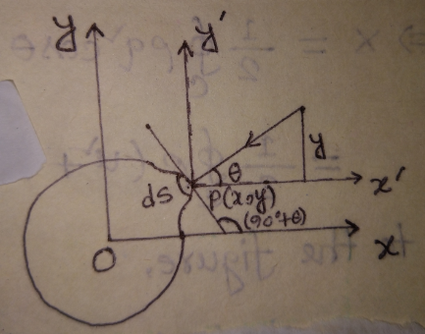

**Proof:** Let be the pressure at  on the cross-section of the cylinder. Let  be the angle which the normal at  make with the positive direction of the axis of .

Then we have

 (1)

 (2)

and  (3)

since the motion is steady and external forces are absent, then we can write from Bernoullis theorem that

 where is a constant

From this we can get



Hence from equation (1), we get













According to the figure,







Similarly, 

and 

 (4)

and 

 (5)

Clearly the curve  is a streamline.

Its equation is given by



From the last two ratios

= 







From equation (4), we get





From equation (5), we have







( **Proved)**

**Problem-01:** A circular cylinder is placed in a uniform stream. Find the force acting on the cylinder. The complex potential for the undisturbed motion is given by .

**Solution:** The complex potential for the undisturbed motion is given by



if we insert a circular cylinder  in the flow field then by circle theorem the new complex potential will be



if the pressure thrust on the contour of the cylinder be represented by a force  and a couple of momentum  then by Blasious theorem

 (1)

and  (2)

Now 

From equation (1), we get







From equation (2), we get









[By Cauchy Residue theorem]

.

Thus .

**Problem-02:** If atwo dimensional motion of a liquid has complex potential  where and  are real and positive, then show that

1. the velocity at infinity is  in the negative sense of the real axis.
2. the circle  is a streamline.
3. there are two stagnation points.
4. the circulation around the circle is .
5. find .

**Solution:** Given that

 (1)

 (2)

if  then from (2), we have



which shows that the velocity at infinity is in the negative sense.

**2nd part:** From (1), we have







Separating real and imaginary parts, we have the velocity potential and stream function respectively.



and 

The lines of equipotential are given by





The streamlines are given by





One of the streamlines is given by



it is possible if 







which shows that the circle is a streamline.

**3rd part:** The stagnation points are given by









which is a quadratic equation in , So there are two values of  and hence there are two stagnation points.

**4th part:** If the pressure thrust on the contour of the cylinder be represented by a force  and a couple of momentum  then by Blasious theorem

 (3)

and  (4)

From equation (3), we get



 [By Cauchy Residue theorem]





Now 







The pole is at  of order .

The residue at  is

















From equation (5), we have







.

**5th part:** On the cylinder  we have



From (1), we have









Equating real and imaginary parts, we have

 and 

From it is obvious that  on , hence it is a streamline. Again in going once round the cylinder  in the direction of  increasing we see that  increases by  and hence





This shows that  decreases by an amount .

But 

 (**Showed**)

**Problem-03:** Show that for a liquid streaming past a fixed cylinder of radius , the velocity potential and the stream function are given by





**OR**

Determine streaming motion past a fixed circular cylinder.

**OR**

Show that the complex potential  represents a streaming motion past a circular cylinder. Hence find the stagnation points.

**Solution:** We know that the uniform stream having velocity  gives rise to a complex potential . We consider .

Now if a circular cylinder is inserted in the flow field, then for the region , we have the complex potential









Equating real and imaginary parts we have,

The velocity potential



the stream function



(**Showed**)

Now 

For stagnation point









Hence the stagnation poins are  and .

The fluid speed is given by





.